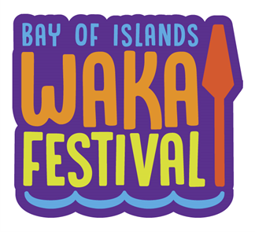

Bay of Islands Waka Festival 2021
Waitangi Kaihoe Waka Ama Clubs’ regatta
Date: Saturday October 2nd and Sunday October 3rd 2021

Launching Te Tii Beach
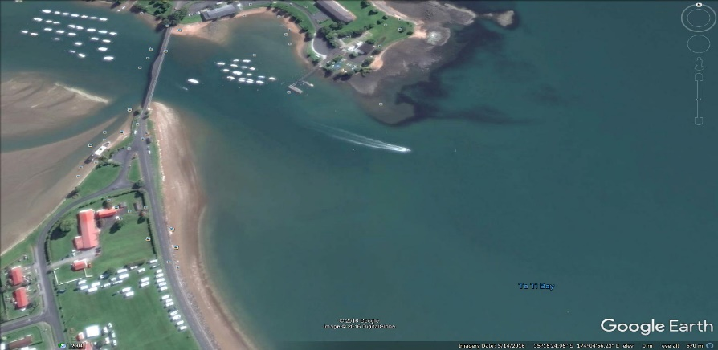
Please note this is a Waka Ama NZ approved event and will run in accordance with Waka Ama NZ Rules

Parking Parking for trailers and cars over the bridge close to boat ramp

Need a Waka? Email us on info@blahblahmarketing.co.nz and we will see if we can help you

Programme Saturday 2nd October 2021
8am to 9am Registration / safety checks – finished by 9am
9am Powhiri / Karakia / Race Briefing – Manuhiri in waka to gather on the water wait for the kaikaranga.
9.30am Race 1: W6 1km Taitamariki, W6 1.5km Intermediates, W6 2km J16
- Races for each age group
- Handicapped starts
- W6 - 1km - Taitamariki - Mixed only
- W6 - 1.5km - Intermediate - Boys, Girls, Mixed
- W6 - 2km - J16 - Men, Women, Mixed

Completed by 11am Registration / safety checks/ Race Briefing for Race 2

11.30 am Race 2: W1 & W2 20km Teams Relay – J16, J19, Opens
      - Teams of 2 (max) for W1 relay
      - Teams of 4 (max) for W2 relay
      - W1 ruddered and W1 rudderless divisions
      - Each team will complete 4x 5km triangle circuits changing team members after a beach run up a chute on completion of each circuit.
      - Winner fastest time overall after handicap taken off.
      - W1 - 20km relay - J16, J19, Open - Men, Women, Mixed - Ruddered, Rudderless
      - W2 - 20km relay - J16, J19, Open - Men, Women, Mixed

Completed by 1.30pm Registration / Safety checks / Race Briefing for Race 3 Races 3a and 3b will start at the same time but the 5km race will paddle round a buoy half way and return so only paddling 5 kms

2pm Race 3: W6 5km Intermediates & W6 10km J16, J19, Open Novice

Race 3a: W6 5km Intermediates
- Age restriction 10yrs – 13yrs, for more confident intermediate paddlers
- This is half the 10km race and will start at the same time as the 10km race
- Only 1 race
- W6 – 5km – Intermediate (10-13yrs) – Boys, Girls, Mixed

Race 3b: W6 10km J16, J19, Open Novice
- Open novice minimum age 14yrs
- W6 – 10km – J16, J19, Open Novice – Men, Women, Mixed

Only 1 race if you need extra waka for your team please organise prior
4pm Prize giving

Programme Sunday 3rd October
8am to 8.30am Registration / safety checks
8.30am Karakia / Race Briefing
9am Race 4: Kris Kjeldsen Memorial Race - Te Taiawhio o Ipipiri. W6 25.4 km J19 & Opens
- Alternate course weather depending will be 23.4km
- W6 only
- A race out into the Bay, around Motuarohia (Roberton Island) to the Western Point of Moturua Island and back to Waitangi
- Staggered start
- Age restriction 16yrs minimum – no exceptions
- Winner will be first waka across the line
- W6 – 25km – J19 & Opens – Men, Women, Mixed

When races finished Prizegiving and thanks

Rules
- All paddlers 16yrs and under must wear a lifejacket for all races – no exceptions
- W6 canoes must have 2 bailers and 6 lifejackets and 1 spare paddle.
- W1 / W2 canoes must have 1 bailer (for sit in canoes), 1 x lifejacket per person and 1 spare paddle.
- All waka will have to pass a safety check and be marked before racing. Any boats not marked will not be permitted to race. (Refer to NKOA Rules for safety equipment requirements). NOTE: Buoyancy Aids/Tubes do NOT constitute a lifejacket.
- For 25km & 10km race essential to have one of these forms of communication (phone/VHF radio/flare etc.)
- All W6 Canoes must have a towrope fitted to the canoe. The rope must be at least 12mm diameter and a minimum length of 25 metres.
- All boats must have spray skirt available on the day. Race organiser’s reserve the right to make spray skirts compulsory if required.
- The Race Organisers have the discretion to cancel the race, refuse entry to crews for any reason related to safety of participants.
- All steerers and team captains must attend the race briefing.
- Should a waka require assistance during the race, the paddler in No.3 seat must hold their paddle up vertically so that an official rescue boat or any passing waka can render assistance.
- In all races W1/W2 must give way to W6. The lead canoe will have right of way.
- On coming waka and craft must approach ‘port to port’ or ama to ama’.
- Competitors should dress appropriately for the conditions (including cooler conditions if required - wet suits, polypropylenes recommended)
- The Race Director and his/her officials have absolute control of the event. They have the discretion to withdraw any competitor or waka which in their opinion is or will be endangering his/her or others safety.
- Race organisers will arrange official support boats, which will be marked with orange flags.
Novice Novice paddlers are considered to be first time members, friends, partners etc. Novice races will continue if weather conditions are suitable.
Notification: In the event of poor weather conditions, please phone 021 124 0382 to check for an update on any possible changes or cancellations.
Cost: Each paddler only pays one fee
- Both days $35pp
- Kris Kjeldsen memorial - Te Taiawhio o Ipipiri $25pp
- Saturday only $20pp
- Kids $5pp – 16yrs and under

Payment Electronic banking – ASB Kerikeri – account name – Waka Ama 2021 –
Account number - 12-3091-0167618-51 – please put your team name and race as a reference.

Contact Anika 021 124 0382 or email info@blahblahmarketing.co.nz if there are any questions or any problems re payment.

SAFETY CHECKLIST
- 1 lifejacket per paddler
- Spray Skirt available (all waka except W1/W2 sit on top)
- Tow rope of 12 mm diameter x 25m long affixed to the waka (W6 Only)
- 2 x bailers W6 / 1x bailer W1/W2
- Spare paddle/s
- Communication equipment e.g. phone/VHF radio/flare etc. specifically for the 10km & 25km race. Must have at least one of these forms of communication.

MAPS (at end of document)
- Map 1: Race 1 Midgets Sat 2nd October 9.30 am start
- Map 2: Race 2 W1 and W2 Sat 2nd October 11am start (Relay x 4)
- Map 3 : Race 2 W1 and W2 Sat 2nd October 11am start (Relay x 4) – Alternate Course
- Map 4: Race 3 W6 Sat 2nd October 2 pm start – 5km race is hallway of 10km race – only 1 start time
- Map 5: Race 4 Kris Kjeldsen Memorial Race - Te Taiawhio o Ipipiri Sun 3rd October Course 1 (Proposed course)
- Map 6: Race 4 Kris Kjeldsen Memorial Race - Te Taiawhio o Ipipiri Sun 3rd October (Alternate Course)

Notes
- Adult steerers are allowed in the Taitamariki race – steering only, no paddling – just as for Nationals. Please note adult steerers cannot be entered in the system with the taitamariki team due toage restriction in system. Please send through steerer name to Anika at info@blahblahmarketing.co.nz
- Kids BYO Water pistols lets have a bit of fun!
- Relay race – only start and finish times no splits
- All on beach finishes but if too rough this will change for the kids races and if unable to run they can have a designated runner
- They maybe food served after the prizegiving on Saturday we will send communication out about this once it is finialised.
- Please with those Junior teams in Race 1 can we have supporters and crew from the teams down on the beach to help make sure we keep our tamariki safe and waka don’t clash when they arrive at the beach.
- Volunteers to help the crew on the day welcome – introduce yourself to the HQ tent on the day! Or email info@blahblahmarketing.co.nz

MEDICAL DISCLOSURE WAKA AMA 2021

Number | Name | Medical condition/s | Medications / on person |  | Drug Allergies | Contact person & No.
 | Joe BLOGGS | Asthma | Symbicort  Ventolin | x | Aspirin, Voltaren etc . exacerbates asthma | Jane BLOGGS  021 234 5678
 |  | Anaphylaxis to wasp stings | Epipen
 |  | High blood pressure | Felodipine | x
Please note this is an example of how this form should be filled in we will allocate your number on the day – this will be written on your arm in Vivid when you are racing –

Competitors with medical conditions that may require medication or treatment urgently e.g. Asthma, history of anaphylaxis, diabetes, are strongly advised to carry any emergency medications/supplies with them at all times. That means with them out on the water, not in a backpack in the car.
Map 1 – Race 1 – Alternate route shown up Waitangi River
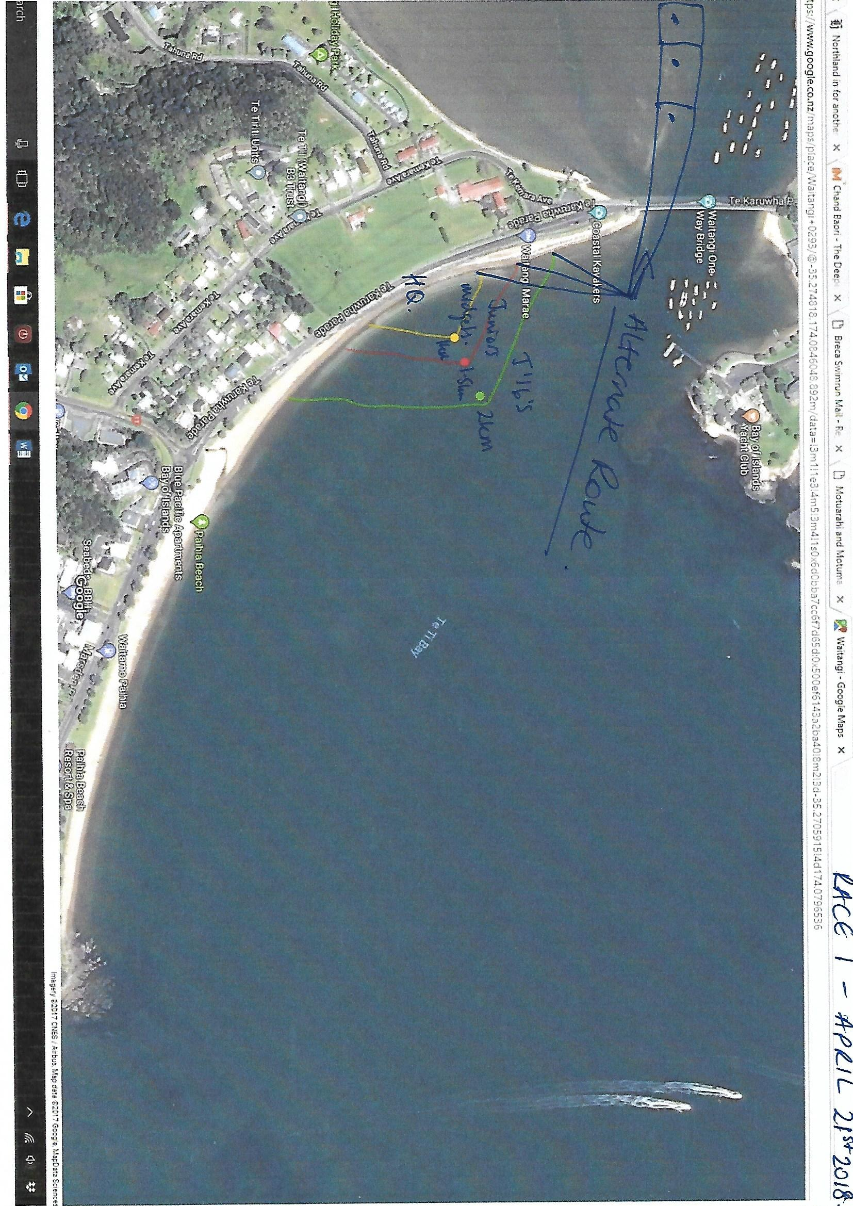

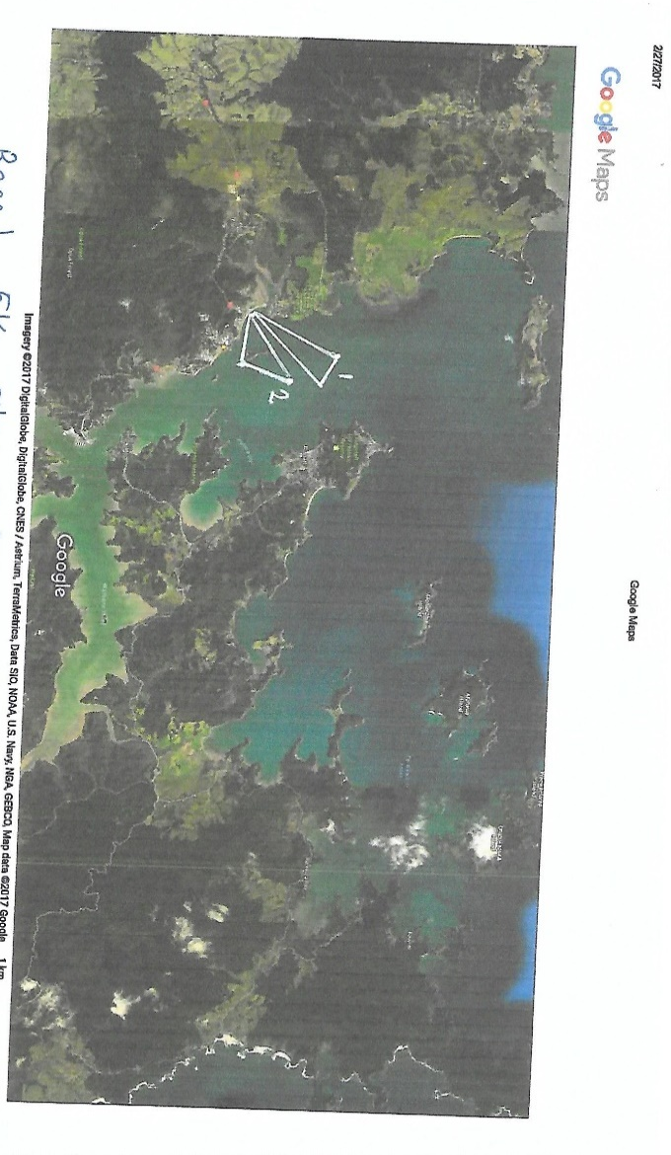
Map 2 - Race 2 – preferred course
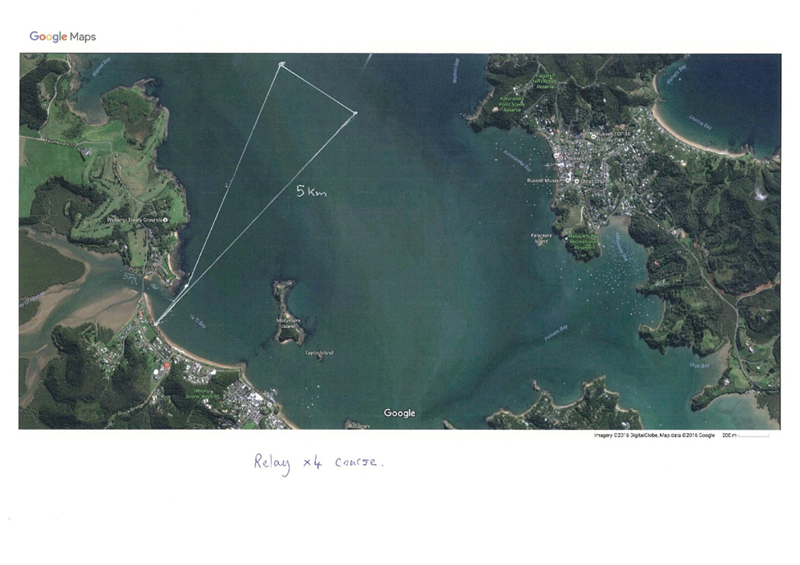

Map 3 - Race 2 Alternate Course shown (2)

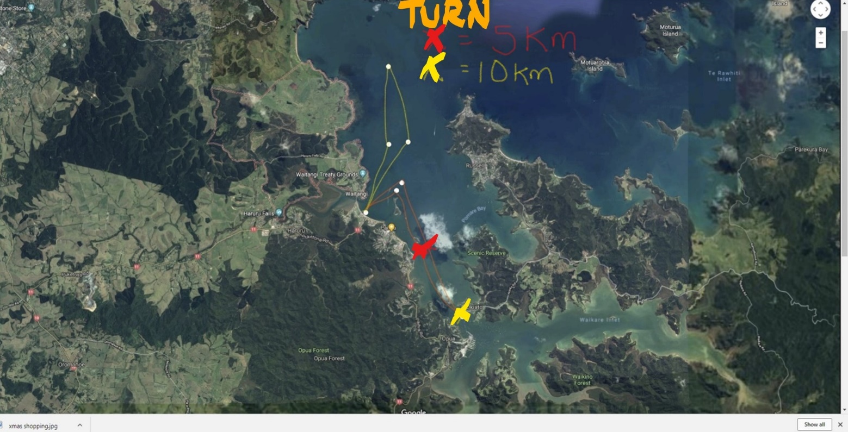

Map 4 – Race 3a and b – Red preferred – Yellow shows alternate course x is for different turn arounds for 5km and 10km race

Map 5 – Race 4 Sunday March 14th Preferred course

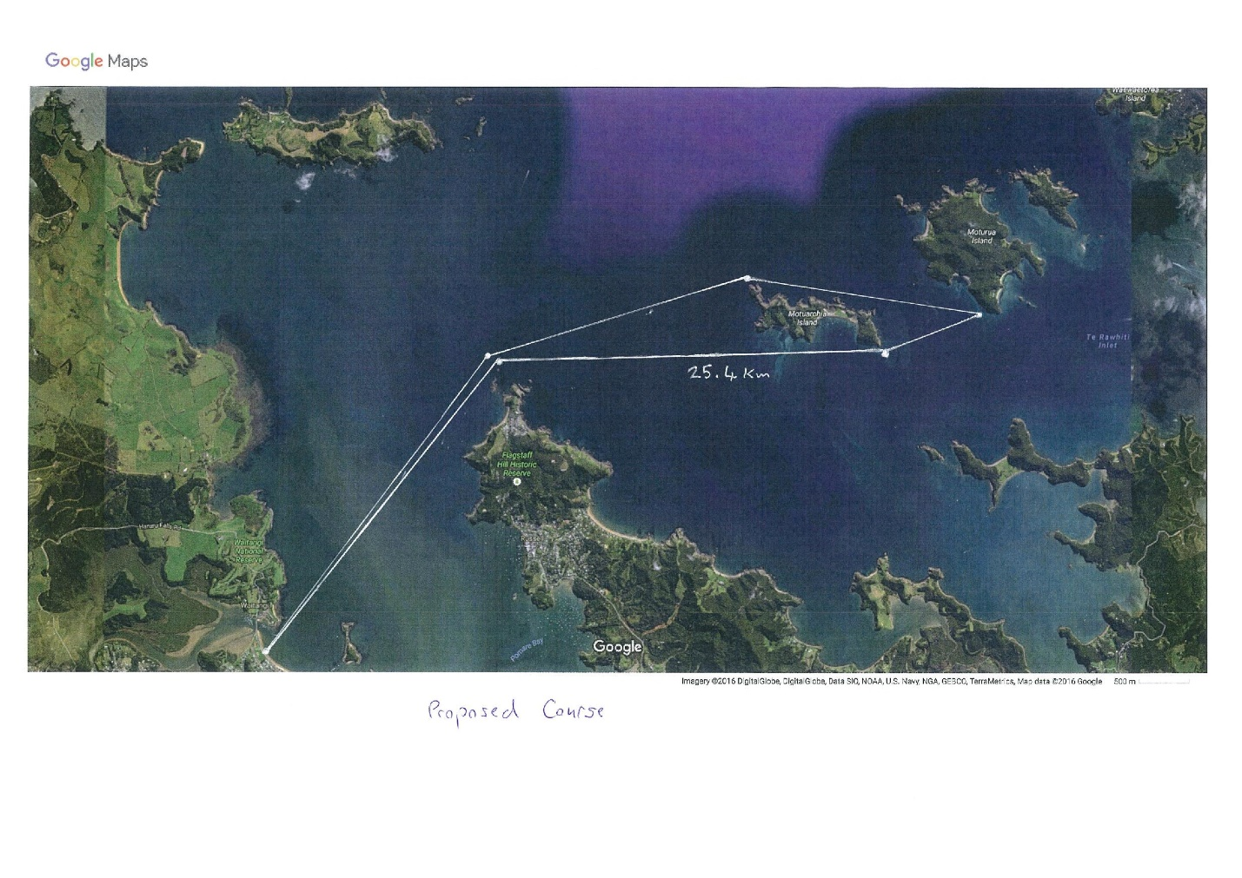

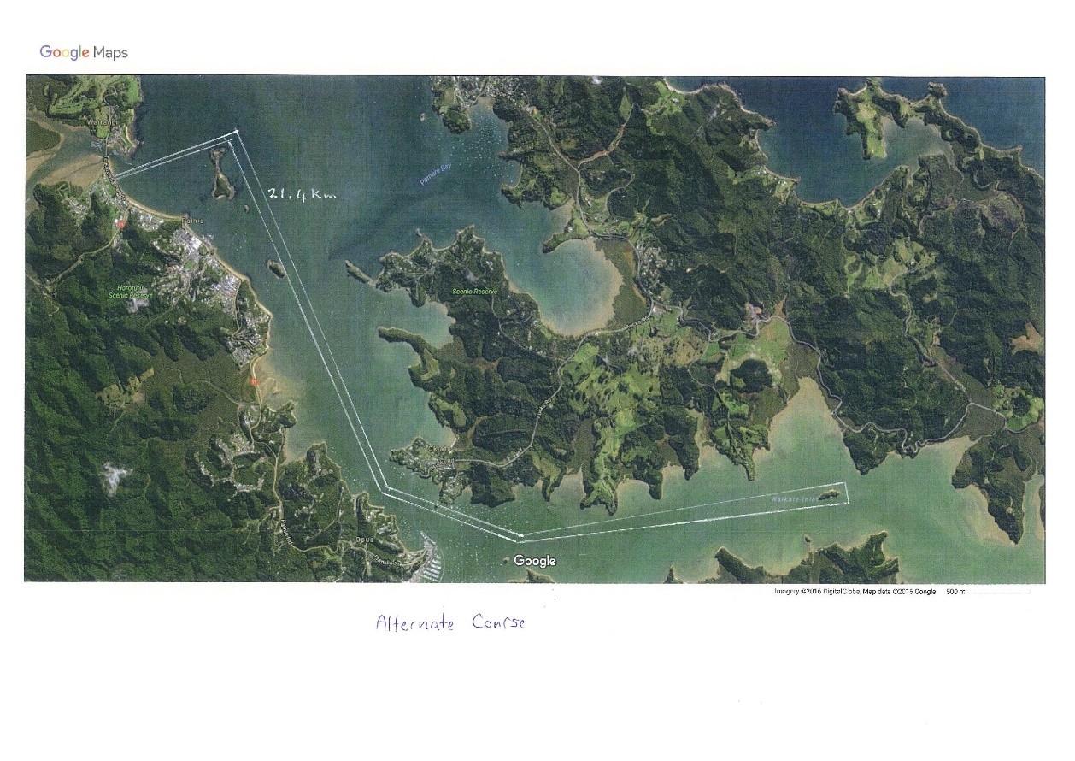
Map 6 – Race 4 Sunday 3rd October – Alternate course.

